信息与管理科学学院计算机科学系
实验报告

课程名称： 软件设计模式与体系结构
实验名称： 6.5-1MVC

姓 名： 张扬
组号： 1 班级：2021级软件 班
指导教师： 王曼曼

实 验 室： 繁塔楼B409
日 期： 2024年5月19日

评分： （百分制）

作业描述：考虑一个拍卖二手车的软件。该软件需要一个用户输入界面，同时还需要显示车的图片，和车的介绍，以及当前的竟拍价格的显示。用户首先从一个列表中挑选要买的车，按Search按纽，得到车的图片与文字介绍，用户输入竞拍价格，另外一个窗口将显示当前的竟拍价格。本系统还应该可以很容易地增添新的数据显示方法。带有灵活的人-机接口的互动的应用。要求相同的信息可以有不同的显示，例如图片，文字介绍等如图所示。
所选中的车的数据
图片表示
文字介绍
当前拍价
在例14.5中，二手车拍卖系统的采用MVC模式(使用观察者机制)的设计与实现，用户输入界面和显示视图都在同一个窗口中显示的情况。本节对二手车拍卖系统的采用MVC模式(使用观察者机制)的设计。在设计中，将用户输入界面和所有的显示视图都放在同一个图形界面中。设计类图如下。
CarFileInfoView
model: CarModel
cg: CarAuctionGUI
+update(): void
CarBitInfoView
model: CarModel
cg: CarAuctionGUI
+update(): void
Controller
-objCarGUI:CarAuctionGUI
-cm: CarModel
-carPrice: String
-carList: String[];
CarAuctionGUI
getSelectedCar()：String
getBitPrice()：String
getCarList()：String[]
setUpComboBox(String[] carList)：void
<<interface>>
Observer
update(Observable subject): void
CarPictureInfoView
model: CarModel
cg: CarAuctionGUI
+update(): void
actionPerformed(ActionEvent e): void
<<interface>>
Observable
CarModel
-carNameList: String[]
-bitPrice: String
-observersList: Vector<Observer>

+setCarList(String[] cars)：void
+getCarList(): String[]
+setSelectedCar(String sCar): void
+getSelectedCar(): String
+setBitPrice(String bPrice): void
+getBitPrice(): String
+setCarFileURL(): void
+getCarFileURL(): URL
+setupImageIcon(): void
+getImageIcon(): ImageIcon
+setBitBtnClickInfo(boolean opt)
+isBitBtnClicked()
+setSearchBtnClickInfo(boolean opt)
+isSearchBtnClicked()
+register(Observer obs)：void
+notifyObservers(): void
+ register(Observer obs): void

作业要求 Homework requirement:
Run the program CarAuctionGUI, in package “例14.5-MVC-Observer -CarInfo-1GUI” and you will see 3 Graphical user interface as below

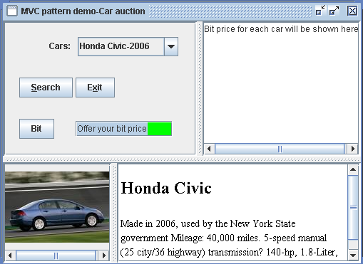

- In the class CarModel, add a method called validateAuctionPrice(String car) to check if a person’s auction price is legal or not. A legal auction price is one that is higher than the last one given. For example, if the latest auction price for Honda Accord-2005 is 6500, and now a customer offers 6400, then this offer is illegal. If now, a person offers 6501, then this offer is legal.
- To implement the above function, in class CarModel.java, you need to change the declaration “private String bitPrice” into 2 statements:
  - private double[ ] currentBitPrices, with
currentBitPrices[0] to record honda accord’s current bit price
currentBitPrices[1] to record honda civic’s current bit price
currentBitPrices[2] to record toyota camry’s current bit price
currentBitPrices[3] to record toyota corolla’s current bit price
- private double[ ] preBitPrices, with
preBitPrices [0] to record honda accord’s previous bit price
preBitPrices [1] to record honda civic’s previous bit price
preBitPrices [2] to record toyota camry’s previous bit price
preBitPrices [3] to record toyota corolla’s previous bit price

3) validateAuctionPrice(String car) shoud be called in class Controller, and in case the offered bit price is illegal, output an error message to the CarBitInfoView, saying “illegal bit price.”

Report part:
- Describe your finished homework, including
    - What method has been added to what class in the existing class hierarchy?
    - What code has been added to what class?

我在CarModel添加了4个方法分别是setBitPrice，getBitPrice，getCarIndex，validateAuctionPrice，它们用来记录拍卖价格并与已有的相比，判断新价格是否合规
代码如下
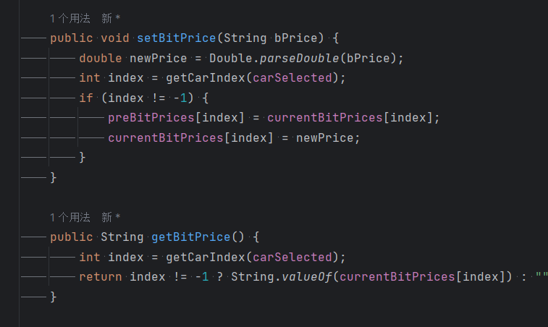
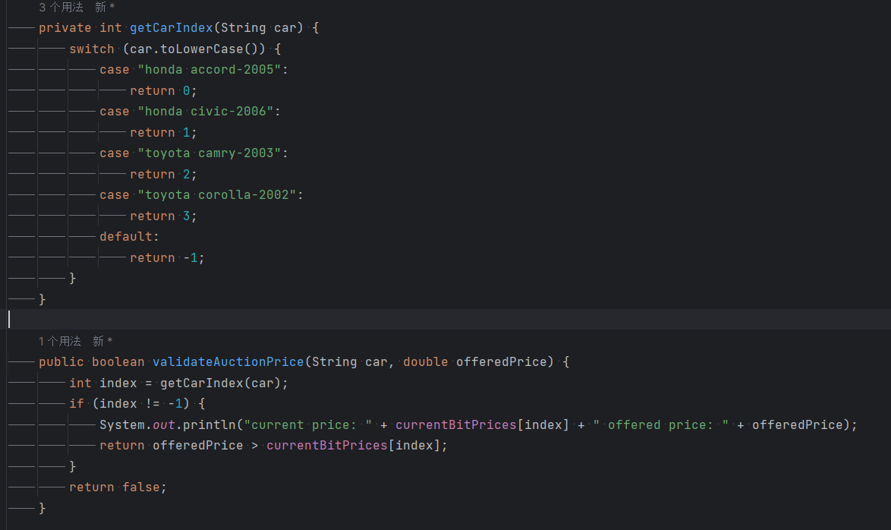
在Controller没有新增方法，但是添加了一部分代码，使得得到的价格传入到CarModel进行判断是否合规，代码如下：
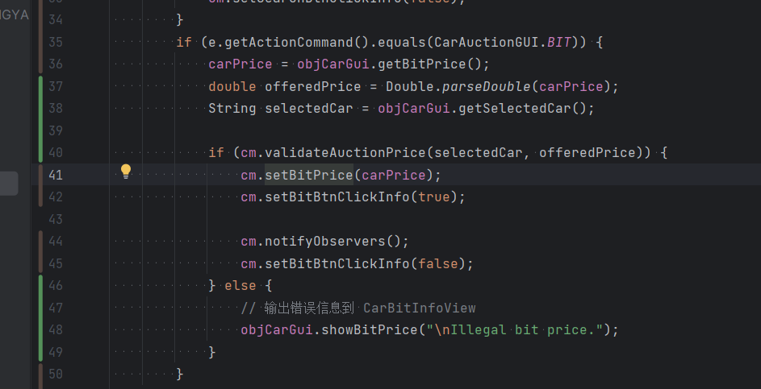
- Draw your new class diagram here, including the newly added method
类图如下：
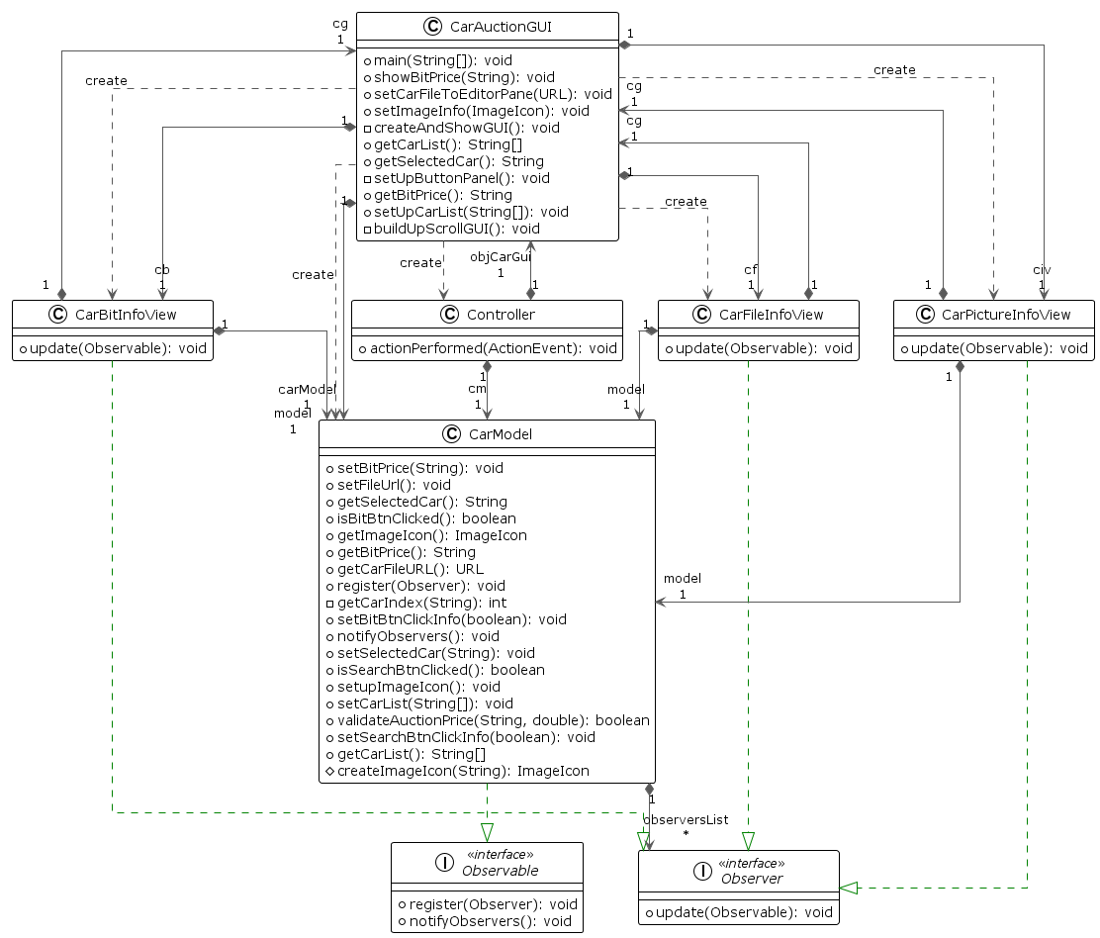

- When a user select Honda Civic-2006, click on search button and then fill in the bit price and then click on the bit button, what methods have been called in your program? List them in correct order.

用户点击搜索按钮时调用了
actionPerformed()，getSelectedCar()，setSelectedCar()，setFileUrl()，setupImageIcon()，setSearchBtnClickInfo(boolean opt)，notifyObservers()，CarPictureInfoView.update()，CarBitInfoView.update(Observable o, Object arg)，CarFileInfoView.update(Observable o, Object arg)，CarModel.setSearchBtnClickInfo(boolean opt)
用户点击出价按钮时调用了
actionPerformed()，getBitPrice()，validateAuctionPrice()
setBitPrice()，setBitBtnClickInfo()，notifyObservers()
CarPictureInfoView.update()
CarBitInfoView.update()
CarFileInfoView.update()
setBitBtnClickInfo()

- Typical input and output from running your program

输入输出如下图：

